Western Australian Certificate of Education  
Mid-Year Examination, 2010

**HUMAN BIOLOGICAL SCIENCE STAGE 2**

**SECTION ONE—MULTIPLE CHOICE *[50 marks]***

|  |  |  |  |  |  |
| --- | --- | --- | --- | --- | --- |
| 1 | **a** | 11 | **c** | 21 | **a** |
| 2 | **a** | 12 | **b** | 22 | **b** |
| 3 | **b** | 13 | **d** | 23 | **b** |
| 4 | **a** | 14 | **d** | 24 | **b** |
| 5 | **c** | 15 | **c** | 25 | **b** |
| 6 | **c** | 16 | **b** |  |  |
| 7 | **c** | 17 | **a** |  |  |
| 8 | **d** | 18 | **d** |  |  |
| 9 | **d** | 19 | **b** |  |  |
| 10 | **a** | 20 | **c** |  |  |

**Section Two: Short answer 50% (80 marks)**

This section has nine (9) questions. Answer all questions. Write your answers in the spaces provided.

Suggested working time for this section is 90 minutes.

**Question 26**

Students were asked to design an investigation that determined what factors affected enzyme activity. They decided that they would investigate the effect of substrate concentration on enzyme activity. They used the enzyme catalase, which is found in yeast. Catalase works to increase the rate of decomposition of hydrogen peroxide into water and oxygen.

The students added 6cm3 of hydrogen peroxide to 3cm3 of yeast. As soon as they added the hydrogen peroxide to the yeast, a gas syringe bung was added to the test tube and they timed how long it took to collect 20 cm3 of oxygen gas. They then repeated the procedure varying the concentration of the hydrogen peroxide each time.

They then repeated this experiment two more times.

The following table shows the results they obtained from their trials.

|  |  |  |  |  |
| --- | --- | --- | --- | --- |
| **Hydrogen peroxide concentration (%)** | **Time taken (seconds)**  **to collect 20 cm3 oxygen gas** | | | **Average Time taken**  **(seconds)** |
|  | Trial 1 | Trial 2 | Trial 3 |
| 4 | 46.3 | 45.3 | 49.1 | **46.9** |
| 8 | 17.4 | 18.0 | 18.9 | **18.1** |
| 10 | 17.5 | 16.3 | 18.1 | **17.3** |
| 12 | 13.5 | 14.5 | 12.2 | **13.4** |
| 16 | 9.3 | 10.1 | 8.4 | **9.3** |
| 20 | 9.0 | 9.4 | 8.9 | **9.1** |

1. Complete the missing column of the table. *[1 mark]*
2. Graph the results on the grid provided on the following page. *[5 marks]*

Question 26b continued.

* **horizontal axis: % of H2O2**
* **correct scale, units**
* **vertical axis: Average time**
* **title**
* **points correctly plotted**

**-1 mark if not a line graph**

1. State the hypothesis that the students were testing. *[1 mark]*

***That enzyme activity plateau once a critical substrate concentration is reached***

***That the concentration of the substrate effects enzyme activity***

1. What was their independent variable? *[1 mark]*

***Concentration of hydrogen peroxide / substrate***

1. What was their dependent variable? *[1 mark]*

***Average time to collect 20 cm3 of oxygen / enzyme activity***

1. Name two variables that were controlled. *[2 marks]*

***Volume of yeast / catalase***

***Volume of hydrogen peroxide***

1. Based on the results collected what conclusions can be drawn about the effect of substrate concentration on enzyme activity? *[2 marks]*

***Incerasing the substrate concentration increases enzyme activity***

***After 16% the enzyme activity no longer increases***

**Question 27**

An artificial cell (see figure below), made from a semi‑permeable membrane and filled with a water solution, was placed in a beaker containing a different solution. The membrane was permeable to water and the smaller sugar molecules, glucose and fructose, but was impermeable to the disaccharide, sucrose.

**Environment**

0.01M sucrose

0.01M glucose

0.01M fructose

**The Cell**

0.03M sucrose

0.02M glucose

0.00M fructose

1. Which solute/s will show net diffusion into the cell? *[1 mark]*

***Fructose***

1. Which solute/s will show net diffusion out of the cell? *[1 mark]*

***Glucose***

____

1. In which direction will there be a net movement of water and what effect will that have on the size of the artificial cell? *[2 marks]*

***Water will move into the cell (1)***

***The cell will increase in volume (1)***

1. Describe the features of an actual cell membrane that would allow the movement of water, glucose and fructose into the cell. *[4 marks]*

***Water moves through protein channels (1) which are always open (1)***

***Glucose and fructose move through a carrier protein (1)***

***When the molecule binds to the carrier protein, the protein changes shape allowing***

***the molecule to enter the cell (1)***

**Question 28**

Complete the table below by writing in the word that best matches the description in the left hand column. *[7 marks]*

|  |  |
| --- | --- |
| The type of graph that would be suitable for displaying the growth of a baby over a two year period. | ***Line*** |
| The main chemical compound that forms the bilayer of a cell membrane | ***Phospholipid*** |
| A type of endocytosis that mainly involves taking liquid into a cell | ***Pinocytosis*** |
| The first phase in the breakdown of glucose | ***Glycolysis*** |
| A tightly coiled thread of DNA that can be seen with a light microscope | ***Chromosome*** |
| A small compound consisting of two simple sugars joined together | ***Disaccharide*** |
| The organelle directly responsible for making protein | ***Ribosome*** |

**Question 29**

Structure of the respiratory system

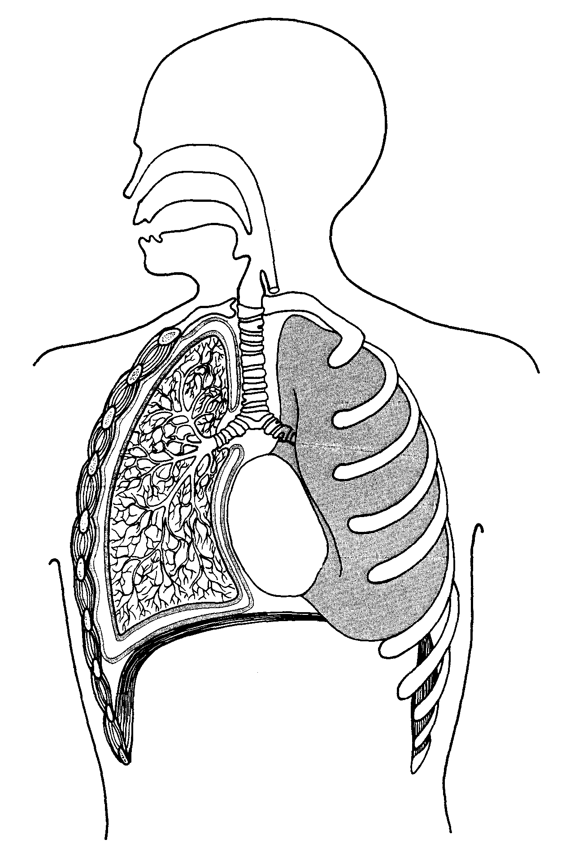

1

2

(air sacs)

(a) Name structures 1 and 2 and explain how each one is suited to its function.

*[4 marks]*

Structure 1

***Alveoli (1)***

***Very thin walls (or large surface area) increase the rate of diffusion (1)***

Structure 2

***Trachea (1)***

***Cilia and mucous trap dust and micro-organisms / cartilage rings prevent collapse***

***of tube during ventilation (1)***

(b) Describe the mechanics behind the process of expiration (breathing out).

*[4 marks]*

**(External) intercostals relax allowing the ribcage to move down and in**

***Diaphragm relaxes, moving upwards***

***The volume of the thorax/lungs decreases***

***Air pressure in the thorax/lungs is increased so air moves out of the lungs to the***

***(relatively) lower pressure outside the body***

(c) People who smoke cigarettes are risking major damage to their health. Name two structures of the respiratory system that suffer damage from cigarette smoking and explain how this damage can impact on the process of breathing. *[4 marks]*

***Any two of the following structures: (2)***

***Trachea, larynx, bronchi, bronchioles, alveoli***

***Any two of the following effects: (2)***

***Damage to cilia in airways leads to reduced filtration - more irritants enter lungs***

***Irritation of airways leads to mucous bulid up - difficulty breathing / reduced***

***FVC% / Coughing & wheezing***

***Damage to alveoli leads to loss of respiratory surface area - decreased gas***

***exchange***

***Damage to alveoli leads to loss of elasticity - difficulty breathing / reduced FVC%***

***Lung cancer - damage to lung tissue / ‘smoker’s cough’***

**Question 30**

Use the diagram below to answer the following questions.

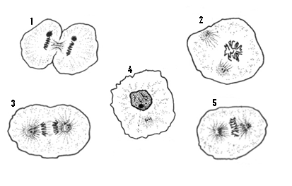

1. Using the numbers from the diagram, list the stages of mitosis in the correct order. *[1 mark]*

**4, 2, 5, 3, 1**

1. What significant event takes directly after Stage 5. *[1 mark]*

***Chromosomes are pulled apart into sister chromatids***

1. Describe how the event you stated in (b) effects the outcome of mitosis.

*[1 mark]*

***Ensures that each cell has a complete copy of DNA***

The graph below shows the changes in the amount of DNA in a cell during one mitotic cycle.

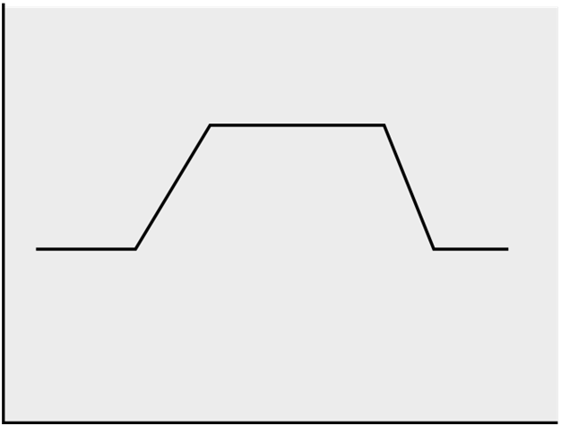

**Changes in the Amount of DNA during Mitosis**

Time (minutes)

Amount of DNA

(arbitrary units)

**A**

**B**

**C**

**D**

**E**

(d) Which stage, or stages, of mitosis occur between:

A-C ____***Interphase***______________________________________________

*[1 mark]*

D-E ____***Telophase***______________________________________________

*[1 mark]*

(e) If the amount of DNA present in a cell at metaphase in mitosis is 10 units, how much DNA will be present in each nucleus immediately following telophase?

_____***5 units***_______________________ *[1 mark]*

Explain your answer.

***During metaphase a cell has two copies of every chromosome, so the total amount***

***of DNA double the normal amount. During telophase that cell splits in two, with***

***each cell taking half the available DNA.***

*[2 marks]*

**Question 31**

The following diagrams show structures of the human digestive system.

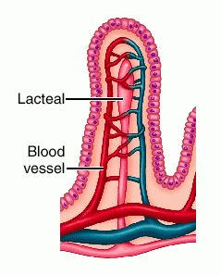

1.

**3.**

Villus

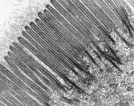

2.

Highly magnified border of one epithelial cell

(a) Name and describe the role of structures 1, 2 and 3 in the absorption of digested food substances. *[6 marks]*

Structure 1

***Lacteal***

***Absorbs fatty acids and glycerol from the intestine***

Structure 2

***Capillary***

***Absorbs water soluble nutrients, such as monosaccharides and amino acids***

Structure 3

***Microvilli***

***Increase the surface area for absorption***

(b)Describe the role of bile in the process of digestion. *[2 marks]*

***Emulsify fat droplets / mechanically breaks large droplets to smaller droplets (1)***

***Increases the surface area for chemical digestion (1)***

**Question 32**

Use the information in the table below to answer the following questions.

|  |  |  |
| --- | --- | --- |
| **Part of the body** | **Rate of blood flow (mL/min)** | |
|  | **When resting** | **When exercising** |
| Skeletal muscle | 1050 | 12500 |
| Digestive system (stomach, intestines, liver) | 1310 | 600 |
| Kidneys | 1100 | 600 |
| Brain | 700 | 710 |
| Skin | 320 | 1900 |
| Heart muscle | 200 | 750 |
| Other organs | 340 | 400 |

Data from Saladin, K ed. *Anatomy and Physiology:* The Unity of Form and Function. 3rd edn. New York: McGraw-Hill, 2004.

1. Calculate the person’s cardiac output when resting.

______***5020 mL/min*** _________________________________________ *[1 mark]*

1. Using your answer in (a), calculate the person’s stroke volume if they had a resting heart rate of 72 bpm.

______***69.7 (70) mL*** _________________________________________ *[1 mark]*

1. From the table, which part of the body is most involved in exercise? Give a reason to support your answer.

***Skeletal muscle as it has the greatest increase in blood flow when exercising***

*[1 mark]*

1. Why is there almost no change in blood flow to brain between rest and exercise?

***Brain has a similar level of activity during rest and exercise***

*[1 mark]*

1. Clearly label the systemic and pulmonary circulations on the diagram below.

*[2 marks]*

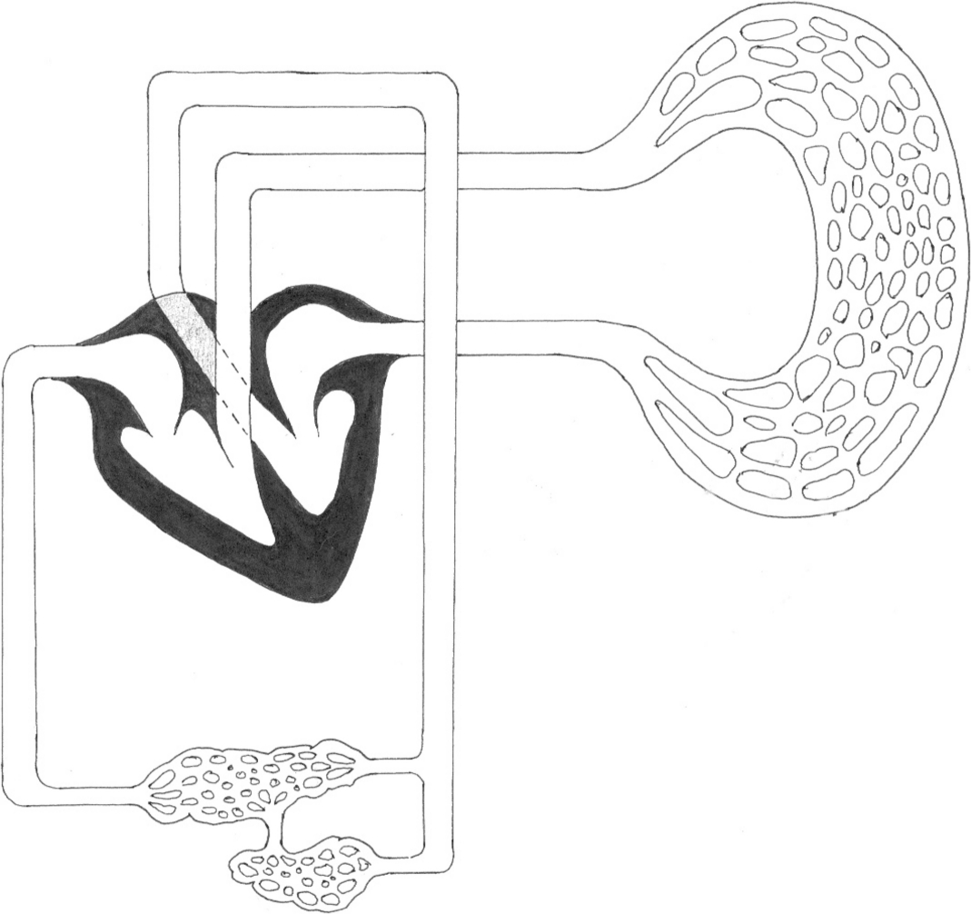

Lungs

Deoxygenated Blood

Oxygenated Blood

Liver

Small Intestine

1. Using two different colours, shade the appropriate sections to illustrate deoxygenated and oxygenated blood on the above diagram. Complete the two boxes for each corresponding colour next to the diagram. *[2 marks]*
2. The hepatic portal vein directly links the liver with the small intestine. What is the purpose of this blood vessel? *[1 mark]*

***To transfer blood that is rich in nutrients (which have just been absorbed) directly to***

***the liver***

1. Explain why the blood in the hepatic portal vein would contain a higher concentration of glucose when compared to a normal vein, but would have the same amount of carbon dioxide. *[3marks]*

***Higher in glucose because this has been added to the blood through absorption***

***from the small intestine (1). Normally glucose would be low because it would have***

***been used in aerobic respiration within cells (1). Carbon dioxide would be the***

***same because it is produced by cells in the small intestine and added to the venous***

***blood just like any other organ (1)***

**Question 33**

The following diagrams show the macroscopic and microscopic structures in the kidneys.

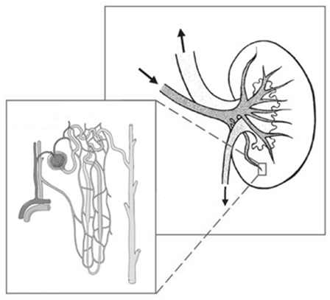

**B** _________

**A** _________

(a) Name Structure A _____***Renal vein***______________________________ *[1 mark]*

Name Structure B _____***Proximal convoluted tubule***________________ *[1 mark]*

(b) What is the function of Structure B? *[2 marks]*

***Selective reabsorption (1)***

***Molecules such as water, glucose and amino acids are reabsorbed from the filtrate***

***to the blood (1)***

(c) List the three main components that make up urine. *[2 marks]*

**Water / urea / ions**

**(1 or 2 = 1 mark / 3 = 2 marks)**

**Question 34**

## The figure below shows the breathing rate of a person at rest breathing different gas mixtures.



Students drew certain conclusions concerning the data shown in the figure. These conclusions, (a) to (f), are listed in the table below. Complete Columns 1 and 2 in the table as follows:

Column 1 write

S If the conclusion is supported by the evidence.

C If the conclusion is contradicted by the evidence.

N If there is no evidence to support or contradict the conclusion from the figure.

Column 2

If your answer to Column 1 is S or C give evidence from the figure to explain your answer.

If your answer to Column 1 is N, leave the space blank.

|  |  |  |
| --- | --- | --- |
| Conclusion | Column 1 | Column 2 |
| (a) The rate of breathing increases markedly in 6% carbon dioxide | **S** | **Breathing rate increases under 6% CO2** |
| (b) A concentration of more than 6% carbon dioxide is fatal | **N** |  |
| (c) There is no marked change of breathing rate under any conditions | **C** | **Both 6% CO2 and 100% O2 affect breathing rate** |
| (d) Temperature is a major factor in increasing the breathing rate | **N** |  |
| (e) The concentration of carbon dioxide plays an important part in governing breathing | **S** | **Changes in the concentration of CO2 clearly affects breathing rate** |
| (f) Lack of oxygen is a stimulus to increasing breathing rate | **C** | **Breathing rate decreases when exposed to 100% O2** |

*[6 marks]*

**Section Three: Extended answer 20% (30 marks)**

This section contains three (3) questions. You must answer two (2) questions. Write in the Standard Answer Booklets.

Responses could include clearly labeled diagrams with explanatory notes; lists of points with linking sentences; clearly labelled tables and graphs; and annotated flow diagrams with introductory notes.

Suggested working time for this section is 50 minutes.

**Question 35**

1. Identify three organs in the body that benefit from a high surface area. For each organ explain how the high surface area is achieved and also the purpose of the high surface area. *[6 marks]*
2. Describe in detail how the body digests a piece of bread. *[9 marks]*

***(a)***

***Lung***

* ***Large number of very small alveoli (1)***
* ***Increases rate of gas diffusion (1)***

***Small intestine***

* ***Length / Large number of folds (villi) / Large number of very small microvilli (1)***
* ***Increases rate at which nutrients can be absorbed (1)***

***Kidney***

* ***Millions of microscopic nephrons (1)***
* ***Allows large quantity of blood to be filtered quickly (1)***

***Can use any other appropriate organ; e.g. brain, placenta***

***(b)***

***(Any 9 of the following 10 points)***

* ***Chewed in mouth***
* ***Increases surface area for enzymes***
* ***Salivary amylase breaks down carbohydrates to smaller poly/disaccharides***
* ***Bolus swallowed / peristalsis in oesophagus to stomach***
* ***No chemical digestion of carbohydrates in stomach / mechanical digestion through churning in stomach***
* ***In duodenum***
* ***Pancreatic amylase and***
* ***Intestinal amylase***
* ***Further break down poly/disaccharides into monosaccharides***
* ***Amylases work best in neutral pH***

**Question 36**

The circulatory system plays a vital role in our bodies.

1. Arteries veins and capillaries are blood vessels. Describe two structural features of each.

*[6 marks]*

1. Explain how one of the structural features you have described for each of the types of blood vessels helps these blood vessels to carry out their function.

*[3 marks]*

1. Describe how gases are transported in the blood. *[6 marks]*

**(a)**

**Arteries**

* **Thick muscular walls**
* **Elastic layer**

**Veins**

* **Valves**
* **Thin walls with little muscle**

**Capillaries**

* **Walls only one cell thick**
* **Very large surface area**

**(b)**

**(Maximum of three points from the list below. Can only have one point for each type of blood vessel)**

**Arteries**

* **Thick muscular walls – able to withstand high blood pressure / able to dilate or constrict to alter blood flow**

**or**

* **Elastic layer – allows elastic recoil to help maintain blood pressure between heart beats**

**Veins**

* **Valves – prevent back flow of blood**

**Capillaries**

* **Walls only one cell thick – increase rate of diffusion**

**or**

* **Very large surface area – increase rate of diffusion**

**(c)**

**(Any 6 of the following points)**

**Carbon Dioxide**

* **As carbaminohaemoglobin in the RBCs (22%)**
* **As bicarbonate ions in the blood plasma (70%)**
* **Dissolved in blood plasma (8%)**

**Oxygen**

* **Dissolved in blood plasma (3%)**
* **As oxyhaemoglobin (97%)**
* **Gives approximate percentages**
* **Gives equation showing the formation of hydrogen carbonate ions from CO2 and water**

**Question 37**

1. Sketch a nephron and label it to show each of the key structures that appear in the table below.

*[3 marks]*

1. Discuss the role of the various regions of the nephron in regulating the composition of body fluid. Use data from the table below to support your answer.

*[12 marks]*

### Concentration of Solutes (micrograms / Litre)

|  |  |  |  |  |  |
| --- | --- | --- | --- | --- | --- |
| Solute | Glomerulus | Bowman’s Capsule | Proximal Convoluted Tubule | Distal Convoluted Tubule | Collecting Duct |
| Protein | 5,000 | 5 | 0.3 | 0 | 0 |
| Glucose | 230 | 230 | 19 | 0 | 0 |
| Urea | 55 | 55 | 50 | 54 | 100 |
| Sodium Ion | 440 | 440 | 50 | 53 | 93 |
| Potassium Ion | 600 | 600 | 60 | 95 | 150 |

**(a)**

**No marks for sketch only**

**0-1 labels correct = 0 marks**

**2 labels correct = 1 mark**

**3-4 labels correct = 2 marks**

**All 5 correct = 3 marks**

**(b)**

* **Filtration occurs in glomerulus and Bowman’s capsule**
* **Large molecules are not filtered**
* **Most proteins are too large**
* **Small molecules such as glucose, ions and urea pass through thus no change in concentration**
* **Reabsorption occurs in the PCT**
* **Significant reabsorption of small proteins and glucose**
* **Some urea is reabsorbed**
* **Some ions reabsorbed**
* **Tubular secretion occurs in the DCT**
* **All glucose and small protein now reabsorbed**
* **Active secretion of chloride ions**
* **Water reabsorption occurs along the length of the tubules**

**Award up to two extra marks for supporting discussion with data from the table**